**Appendix 1**: Supplementary Figures

**Figure A1**: Example calculation of SDC curves (panel e) fit to four hypothetical fires, with 1000 ha of stand-replacing fire distributed in 1, 10, 1000 and 1000 ha patches (panels a-d). Distribution of ln(SDC) values shown in panel f, with colored lines matching panel e. Modified from Collins et al. (2017).

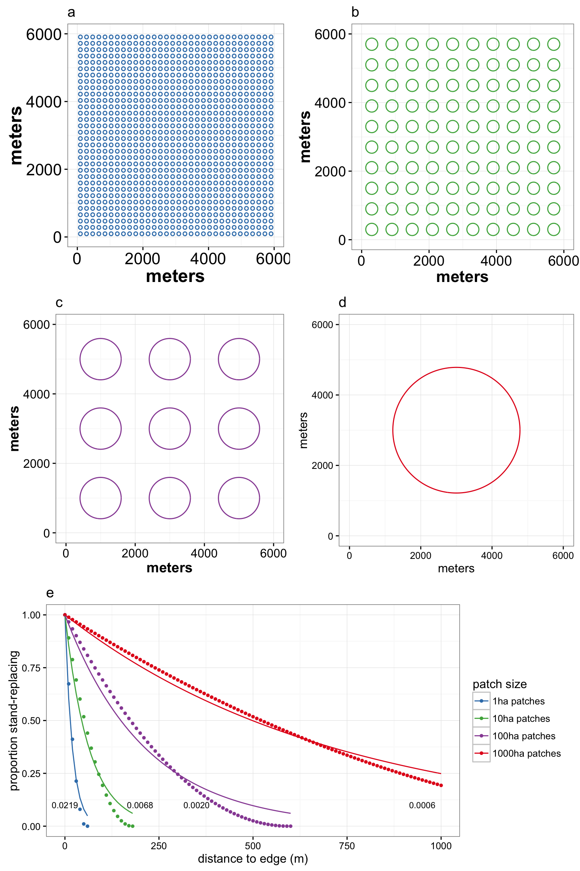

f



**Figure A2**: Range of possible SDC values as a function of average patch radius (radius given as *r* in m, area given as *a* in ha).

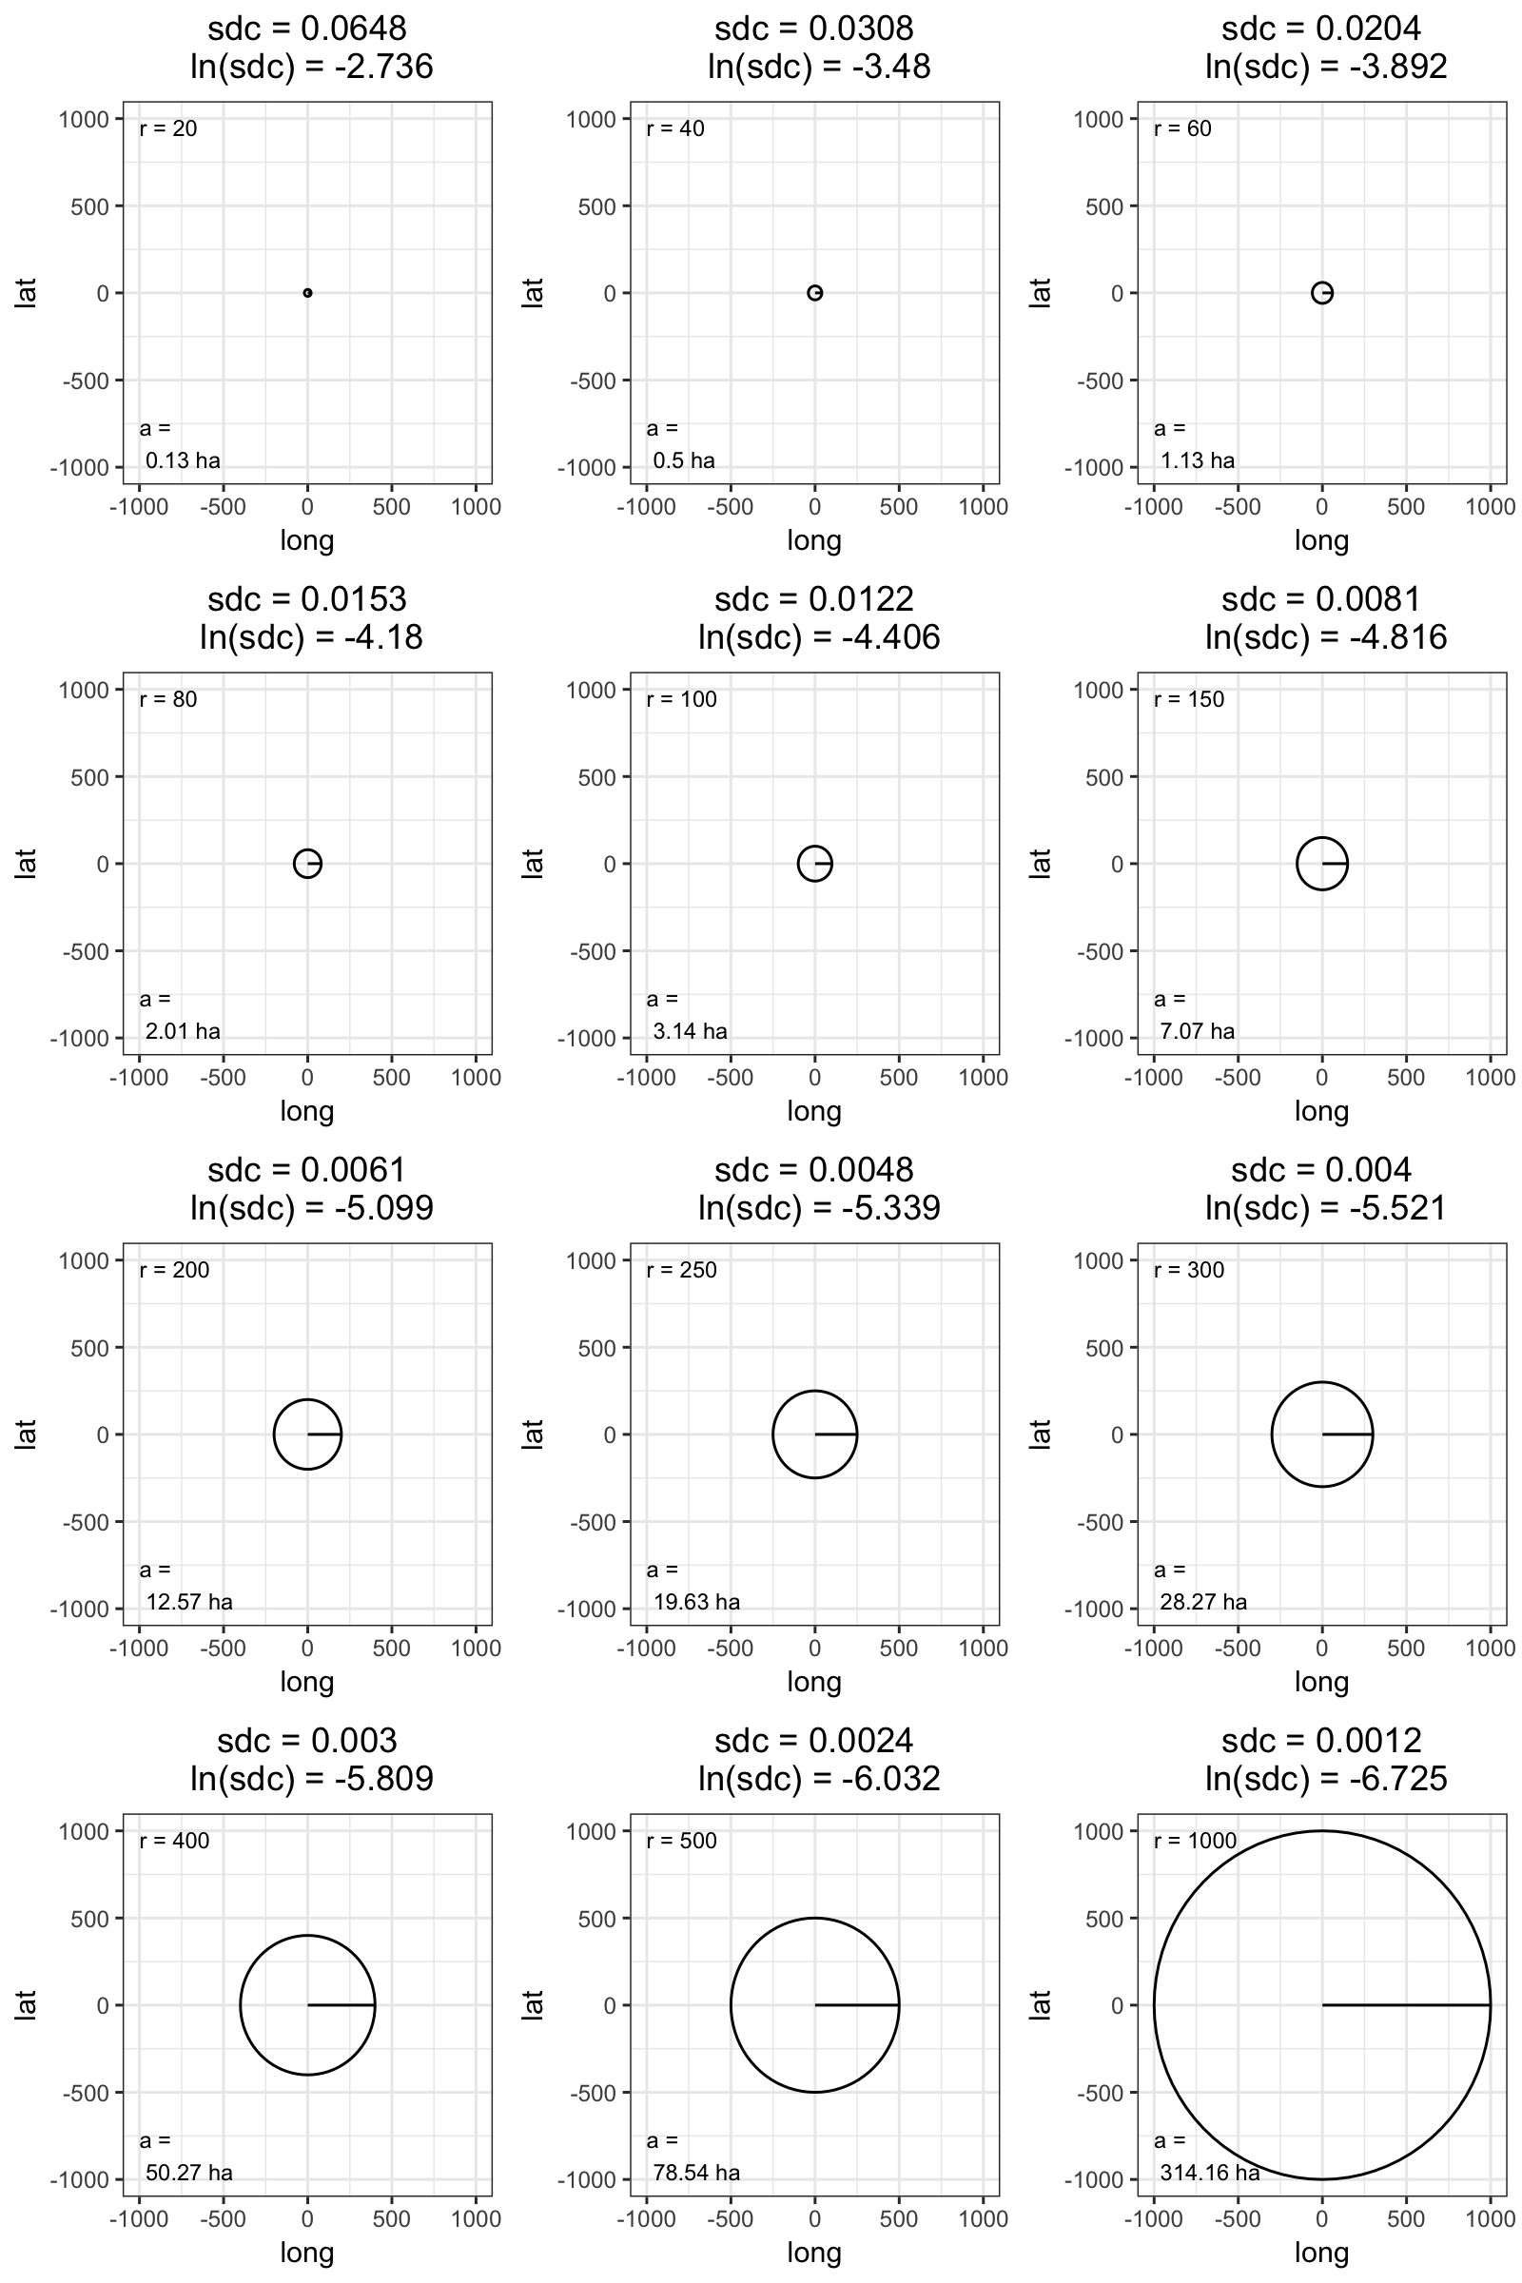

**Figure A3**: Change in ln(SDC) over time, distinguishing between the Southern Cascade/Sierra Nevada (red) region and northwestern California (teal). The trend of decreasing mean annual ln(sdc) was significant in the SCSN (R2 = 0.12, t = 2.05, P = .049) but not in NW (R2 = 0.004, t = 0.32, P = .750). Shaded bands represent 95% confidence interval around regression line.

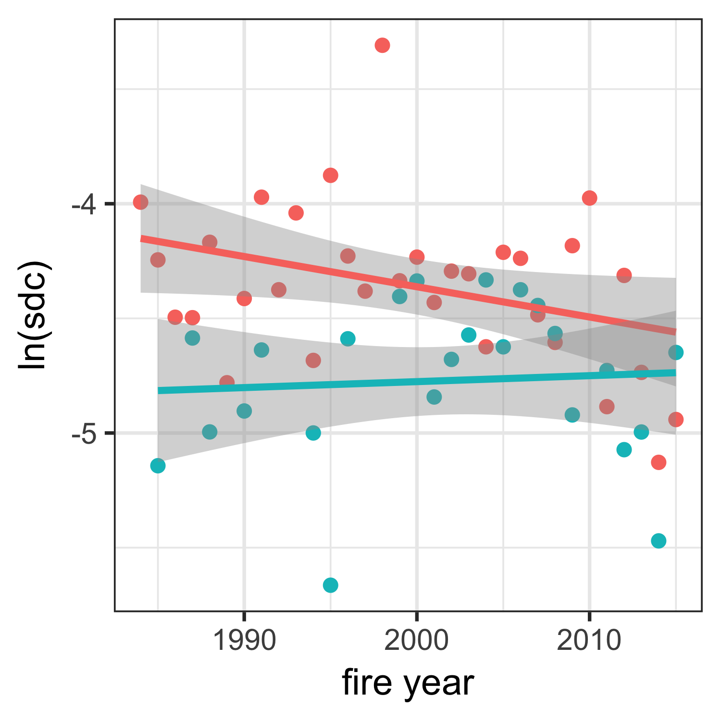

**References:**

Collins, B.M., Stevens, J.T., Miller, J.D., Stephens, S.L., Brown, P.M., North, M.P., 2017. Alternative characterization of forest fire regimes: incorporating spatial patterns. Landsc. Ecol. 32, 1543-1552